Analytical Report for Nutrition BMINDS Food Insecurity Survey and stress Responses
Executive Summary
The report provides an in-depth analysis for 862 respondents after data cleaning and processing. The variables used are Food Security with FIES Score and FIES Level, Resilience with Resilience Total and Resilience Level, Stress Mindset with Stress Mindset Total and Stress Mindset Level, and Psychological Distress with K10_total and K10_category.

Exploratory Data Analysis showed that most variables follow non-normal distributions, which must be analyzed through non-parametric tests. Spearman Correlation tests showed moderate negative correlations between Food Security and Psychological Distress (r = -0.24, p < 0.001), which indicated that lower levels of food security correlate to increased psychological distress. Also, gender comparisons through Mann-Whitney U tests showed significant contrasts in Stress Mindset Total (p < 0.001). Moreover, there is a strong positive correlation between Food Security and Family Incomes (r = 0.39, p < 0.001); yet, no significant relationship was seen between GPA and Stress Mindset.

Introduction
This report aims at conducting an exploratory analysis on the data. The data has 862 participants and consists of 85 variables after data cleaning. Some of the key variables that the data uses include:
- Food Security (FIES score, FIES level)
- Resilience (Resilience Total, Resilience Level)
- Stress Mindset (Stress Mindset Total, Stress Mindset Level)
- Psychological Distress (K10_total, K10_category)

Analysis would involve evaluating descriptive statistical information, distributions, and the associations between various measures to possibly detect differences, patterns, and correlation that would be pertinent to further studies.
Exploratory Data Analysis (EDA)
- Descriptive Statistics
Metric | Count | Mean | Median | SD | Min | Max
FIES score | 862 | 1.79 | 0 | 2.47 | 0 | 8
Resilience Total | 862 | 18.43 | 18 | 2.15 | 11 | 30
Stress Mindset Total | 862 | 13.71 | 14 | 5.65 | 0 | 32
K10 total | 862 | 32.66 | 32 | 3.55 | 23 | 46
Analysis would involve evaluating descriptive statistical information, distributions, and the associations between various measures to possibly detect differences, patterns, and correlation that would be pertinent to further studies.

Observations:
- K10 total reveals the concentration of values to be indicative of psychological distress among the participants.
- Stress Mindset Total has a large variation in scores among participants, ranging from extreme low scores to extreme high scores
- FIES score and Resilience Total are moderately skewed and mostly concentrated along the mean.

- Distribution Across Categories
Food Security (FIES level):
- Categories: “very low food security”, “low food security”, “marginal food security”, “high food security”.
- K10 total lowers as food security improves.
- The distribution of the scores leans to the side of low FIES score, which signifies higher food insecurity among the participants.

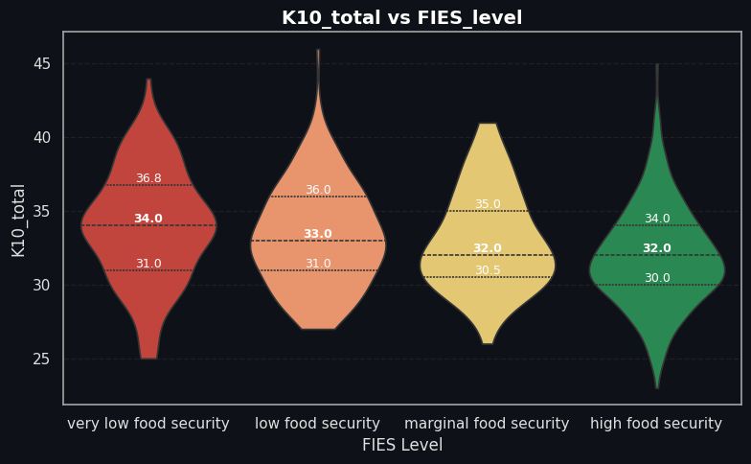

Stress Mindset by Gender:
- Mann-Whitney U-test demonstrated significant difference in the beliefs among males and females (p < 0.001).
- Females have a slightly greater Stress Mindset Total than males.

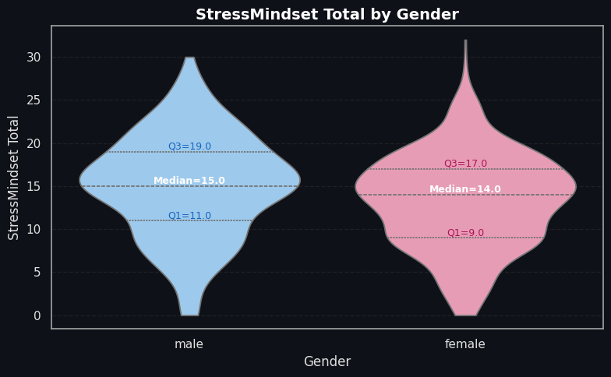
Stress Mindset by GPA:
- Not significant for the comparison across categories for Stress Mindset Level (Spearman r = 0.02, p = 0.65).
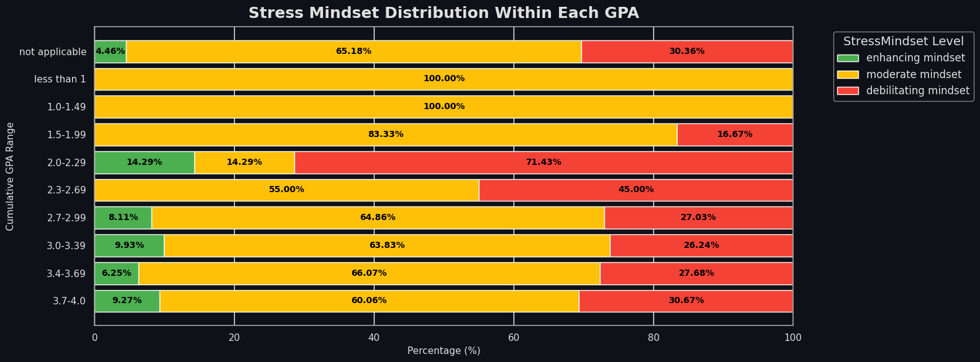
Food Security by Household Income:
- High positive correlation between variables FIES level and income (r = 0.39, p < 0.001).
- Higher income households have higher levels of food security.
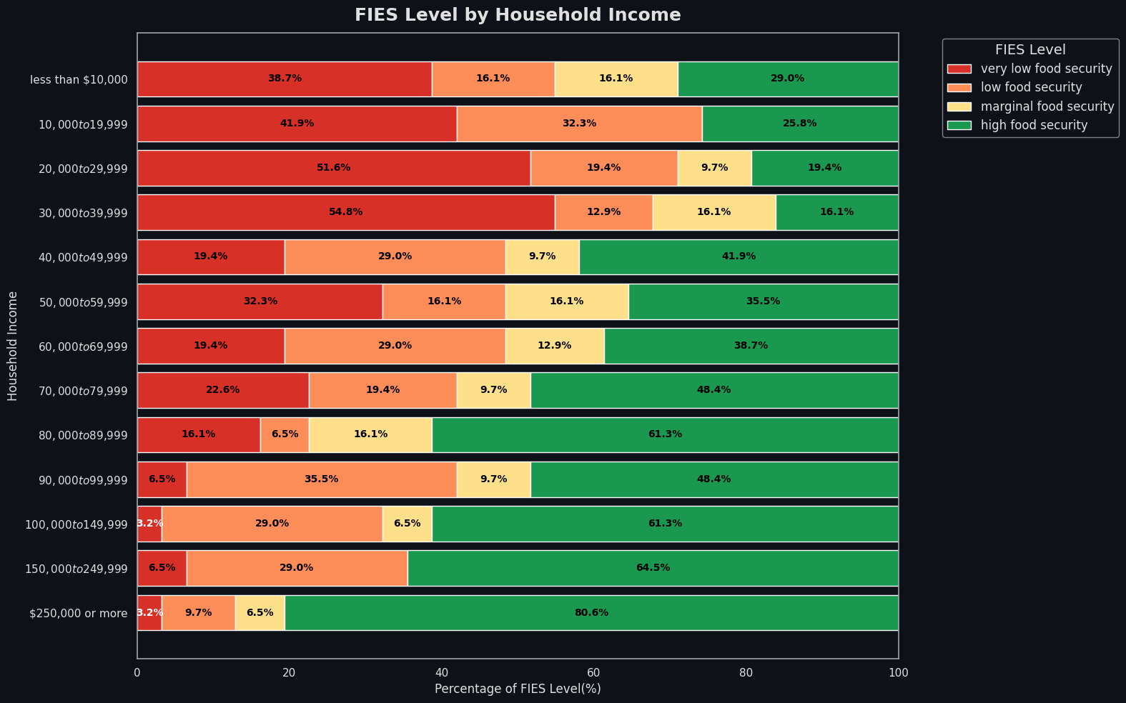

- Variable Relationships
Relationship | Spearman r | p-value | Interpretation
FIES level vs K10_total | -0.24 | <0.001 | Lower food security → higher psychological distress
Stress Mindset level vs GPA | ------- | 0.65 | No significant relationship
FIES level vs Income | 0.39 | <0.001 | Higher income → higher food security
Gender vs Stress Mindset Total | ------- | <0.001 | Females higher on average than males

Observations:
- Food security is one of the influential factors concerning psychological distress.
- Gender differences exist in coping strategies, reflected in Stress Mindset Total.
- Household income contributes highly to food insecurity, which indirectly affects mental health.

Discussion
- Descriptive Insights:
- Participants generally exhibit moderate resilience (mean = 18.43) and average stress mindset (mean = 13.71).
- Elevated K10_total scores suggest a notable prevalence of psychological distress in the sample.
- Relationships and Implications:
- The negative correlation between FIES level and K10_total highlights food security as a protective factor.
- Significant gender differences in Stress Mindset Total suggest interventions should be gender-sensitive.
- Lack of correlation between GPA and Stress Mindset indicates academic performance is not a predictor of coping ability.
- Strong correlation between income and FIES level emphasizes the role of socioeconomic status in food security and mental health.
- Factors Affecting Psychological Distress:
- Primary contributors include food security, stress mindset, gender, and household income.
- These variables interact to influence overall mental health, suggesting multi-dimensional interventions are necessary.

Recommendations and Further Work
Practical Recommendations:
- Implement programs to improve food security among low-income participants.
- Develop gender-specific interventions to enhance coping strategies.
- Monitor mental health indicators periodically to identify high-risk groups.
Future Analytical Steps:
- Collect additional variables for more comprehensive analysis.
- Explore predictive modeling to identify key factors for psychological distress.
- Analyze interactions between measures for deeper insights.

